System Specification

Adam Satria Adidarma; Gayuh Kautaman Rahmad

# 1. Software Description

### 1.1 General Description of The System

This system is an application software with the main function to determine in a given location and timespan if the air quality is good or bad. The system calculates the four main attribute (O3, SO2, NO2, PM10) values that characterize the air quality in these areas. The data that is retrieved by the system ranges from January to December of 2017. This application allows the user to view the air quality result of a given sensor and timespan with all the average attribute values that characterize the air quality. It also gives users an approximation of sensors with similar attribute values.

### 1.2. Product Functionality

This section is to outline the use cases of the air quality management system, with the user as the main actor in this system.

#### **1.2.1 User Use Case**

The User has the following sets of use cases:

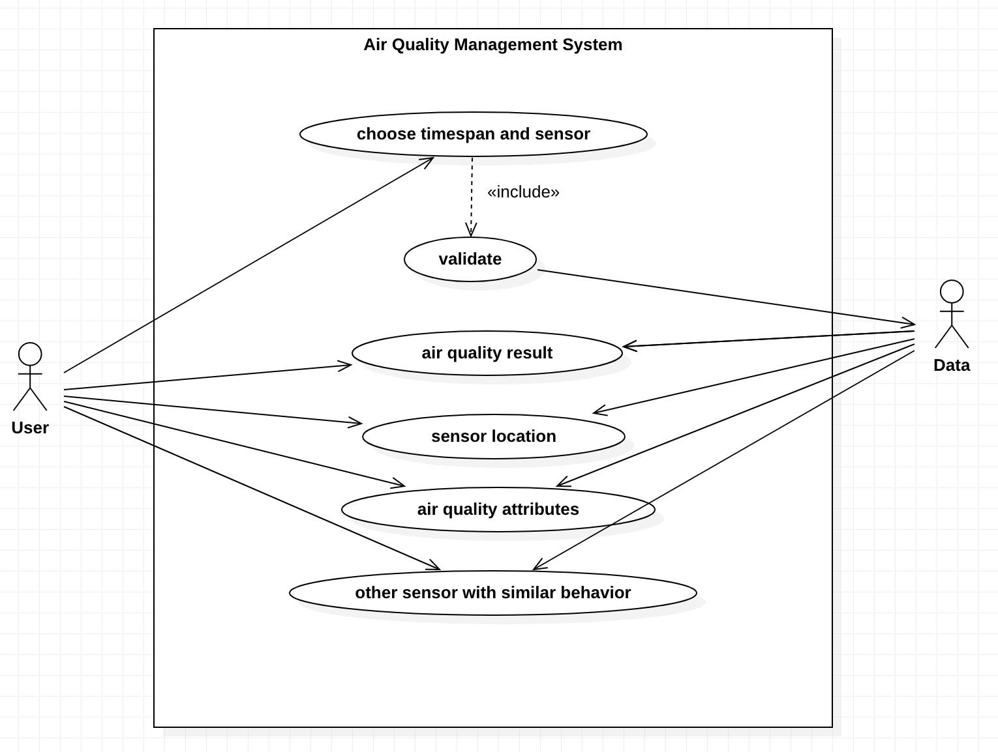

**Use Case**: View Air Quality Result

**Brief Description**

The user chooses the sensor and timespan to view the air quality from the chosen parameters.

**Initial Step by Step Description**

Before this use case can be initiated, the User must have access to the Air Quality Management software.

1. The User chooses a sensor and gives the timespan.
2. The system links to the data.csv file that has been provided to validate the user inputs.
3. If the inputs are validated, the system will calculate the average values of each attribute of the given sensor and timespan from the data.
4. The system returns the air quality result to the User.

**Use Case**: View Sensor Location

**Brief Description**

The User views the sensor location of a given sensor.

**Initial Step by Step Description**

Before this use case can be initiated, the User must have access to the Air Quality Management software.

1. The User chooses a sensor and gives the timespan.
2. The system links to the data.csv file that has been provided to validate the user inputs.
3. If the inputs are validated, the system will get the longitude and latitude of the sensor from the data.
4. The system will then mark the location for this sensor on the main window for the User to see.

**Use Case**: View Air Quality Attributes

**Brief Description**

The User views the attribute value of the given sensor and timespan.

**Initial Step by Step Description**

Before this use case can be initiated, the User must have access to the Air Quality Management software.

1. The user chooses a sensor and gives the timespan.
2. The system links to the data.csv file that has been provided to validate the user inputs.
3. If the inputs are validated, the system will calculate the average values of each attribute of the given sensor and timespan from the data.
4. The system returns the air quality result to the user along with its comprising attribute values.

**Use Case**: View Other Sensors With Similar Behavior

**Brief Description**

The User views other sensors with similar behavior with the user’s chosen sensor.

**Initial Step by Step Description**

Before this use case can be initiated, the User must have access to the Air Quality Management software.

1. The user chooses a sensor and gives the timespan.
2. The system links to the data.csv file that has been provided to validate the user inputs.
3. If the inputs are validated, the system will do the calculation of the average values in each attribute of every sensor in the given timespan from the data.
4. The system will return the air quality result of the chosen sensor along with other sensors that have similar attribute values from the chosen sensor.

### 1.3 User Characteristics

Our User characteristics are described in the following table:

|  |  |  |  |
| --- | --- | --- | --- |
| Actor Category | Task | Access Right | Minimal Ability |
| User | - Choose a sensor and its timespan  - See the results of air quality calculation with its comprising attributes, sensor map location, and sensors with similar behavior | User | Understanding of basic computer use |

### 1.4 Software Limitation

The Air Quality Management software has the following limitation:

1. The software pulls data from an old CSV file of 2017.
2. The software is built using C++ with a QT framework.
3. The user interface is not responsive for mobile devices.

### 1.5 Operational Environment

The operating environment to run this Air Quality Management software is as follows:

1. Any machine that has a working linux operating system and is capable of taking inputs from keyboards and mouse.

# 2. Requirement Description

### 2.1 External Interface Requirements

#### **2.1.1 User Interface**

Users can access this software using any machine that can run Linux operating system on their machine, using the mouse and keyboard as their inputs.

#### **2.1.2 Hardware Interface**

Since this software needs to connect to the OSM API to display map locations, all the hardware is required to have access to the internet via Modem, WAN-LAN, or Ethernet Cross-Cable.

#### **2.1.3 Software Interface**

The software interface of this program is developed using Qt framework with C++ programming language, and QML for map rendering.

### 2.2 Functionality Description

**2.2.1 View Air Quality Result**

|  |  |
| --- | --- |
| Use Case | View Air Quality Result |
| No | FD-001 |
| Description | The user sees the air quality result. |
| Actor | User |
| Start Condition | The user opens the air quality management software. |
| End Condition | The user can view the air quality result |
| Normal Flow | 1. User starts the software executable file.  2. User input the sensor and timespan.  3. System links to the CSV data file to validate the user inputs.  A1. User input the wrong timespan value.  4. System will calculate the average values of each attribute of the given sensor and timespan from the data.  5. System will return the air quality result based on those values.  6. The user can view the air quality result of the chosen inputs. |
| Alternate Flow | A1. User input the wrong timespan value   1. The system will throw an error message on the console. 2. The system will ask for another input from the user. 3. User input a valid timespan value. 4. Done. |
| Special Requirements | Users must have access to the software and the data that links to the software |

**2.2.2 View Air Quality Attributes**

|  |  |
| --- | --- |
| Use Case | View Air Quality Attributes |
| No | FD-002 |
| Description | The user sees the air quality attributes of the result. |
| Actor | User |
| Start Condition | The user opens the air quality management software. |
| End Condition | The user can see the air quality attributes |
| Normal Flow | 1. User starts the software executable file.  2. User input the sensor and timespan.  3. System links to the CSV data file to validate the user inputs.  A1. User input the wrong timespan value.  4. System calculates the average values of each attribute of the given sensor and timespan from the data.  5. System stores the results of each calculation and returns the air quality result along with its comprising attributes.  6. The user can see the values that define the air quality result. |
| Alternate Flow | A1. User input the wrong timespan value   1. The system will throw an error message on the console 2. The system will ask for another input from the user 3. User input a valid timespan value 4. Done |
| Special Requirements | Users must have access to the software and the data that links to the software |

**2.2.3 View Sensor Location**

|  |  |
| --- | --- |
| Use Case | View Sensor Location |
| No | FD-003 |
| Description | The user views the sensor location on a map. |
| Actor | User |
| Start Condition | The user opens the air quality management software. |
| End Condition | The user can view the location of a sensor they chose. |
| Normal Flow | 1. User starts the software executable file.  2. User input the sensor and timespan.  3. System links to the CSV data file to validate the user inputs.  A1. User input the wrong timespan value.  4. The system will get the longitude and latitude of the chosen sensor from the data.  5. The system will mark the location of this sensor on the main window.  6. Users can see the sensor location that they choose. |
| Alternate Flow | A1. User input the wrong timespan value   1. The system will throw an error message on the console 2. The system will ask for another input from the user 3. User input a valid timespan value 4. Done |
| Special Requirements | Users must have access to the software and the data that links to the software |

**2.2.4 View Other Sensors With Similar Behavior**

|  |  |
| --- | --- |
| Use Case | View Other Sensors With Similar Behavior |
| No | FD-004 |
| Description | The user views other sensors with similar behavior with the user’s chosen sensor. |
| Actor | User |
| Start Condition | The user opens the air quality management software. |
| End Condition | The user can view list of other sensors with similar behavior with user’s chosen sensor. |
| Normal Flow | 1. User starts the software executable file.  2. User input the sensor and timespan.  3. System links to the CSV data file to validate the user inputs.  A1. User input the wrong timespan value.  4. The system will do the calculation of the average values in each attribute of every sensor in the given timespan from the data.  5. The system will return lists of other sensors with similar attribute behavior with user’s chosen sensor.  6. The user views the list of other sensors with similar behavior with user’s chosen sensor. |
| Alternate Flow | A1. User input the wrong timespan value   1. The system will throw an error message on the console 2. The system will ask for another input from the user 3. User input a valid timespan value 4. Done |
| Special Requirements | Users must have access to the software and the data that links to the software |